**User guide:**

**Main menu:**

This section will always be on top of all pages of the website; from here users can easily jump into any categories at any time or return to the homepage by clicking on the name of the elements in the menu which they are interested in.

***Figure – 1***

*(Users move to World Bridges page from homepage by clicking on* ***World Bridges****)*

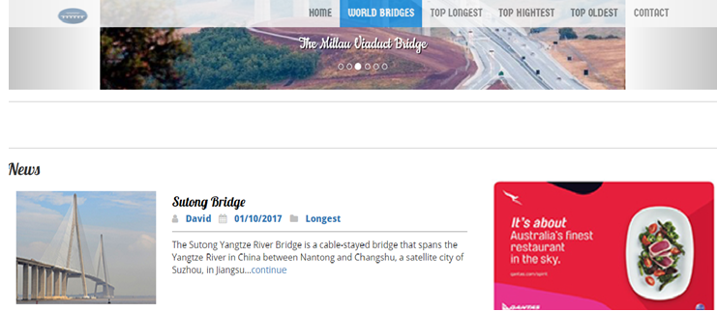

***Figure – 2***

*(Users return to homepage from Top Highest page by clicking on* ***Home****)*

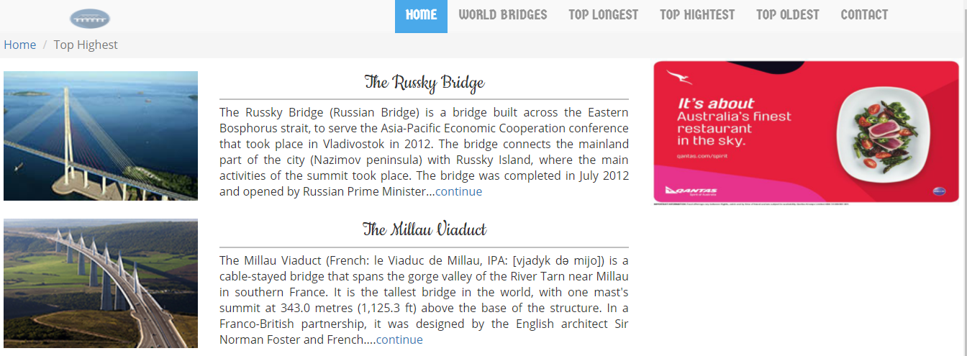

**Sub - menu:**

Visitors are allowed to point to any part on Detail page of the bridge which they are reading through this section on the right side of the page.

***Figure – 3***

*(Figure – 3 shows the submenu)*

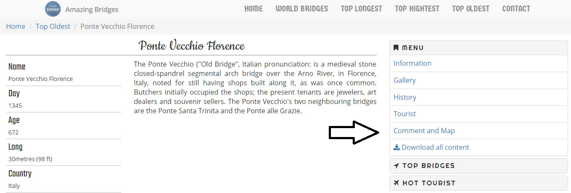

***Figure – 4***

*(Web – viewers select* ***Gallery****)*

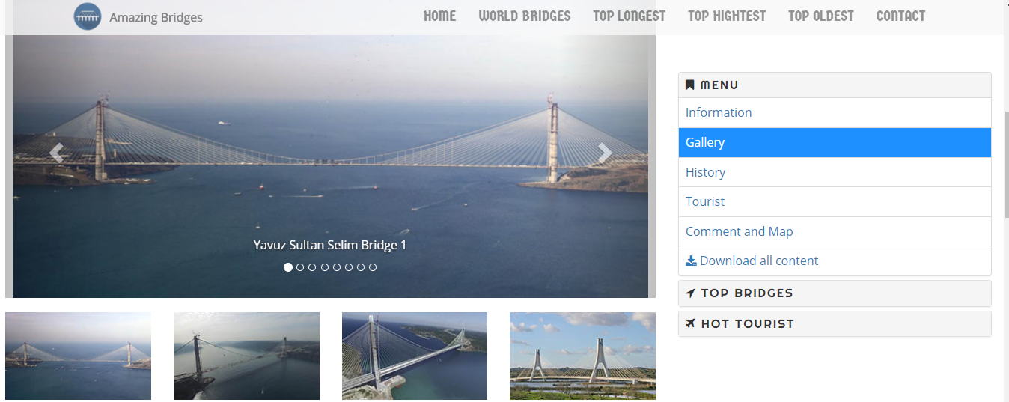

***Figure – 5***

*(Web – viewers select* ***Comment and Map****)*

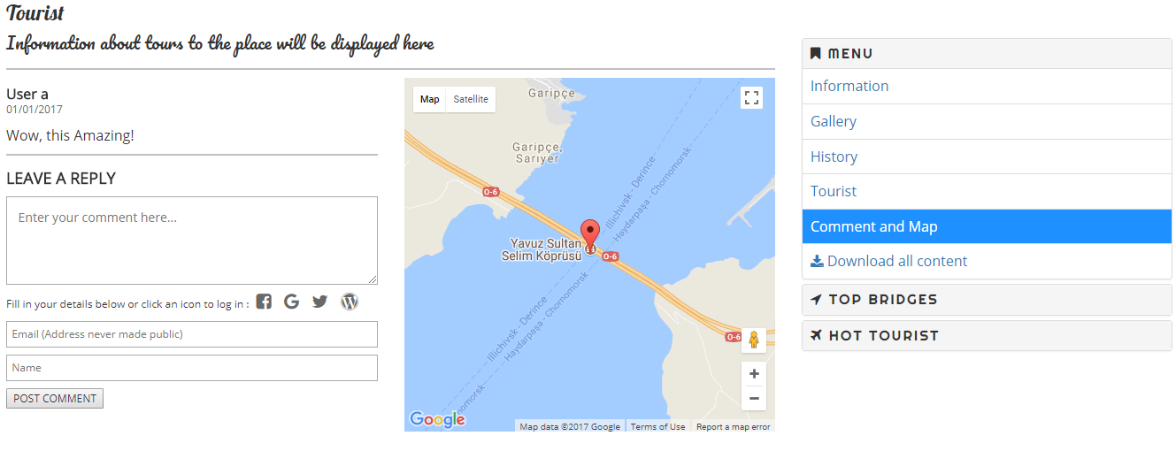

***Figure – 6***

*(Web – viewers select* ***History****)*

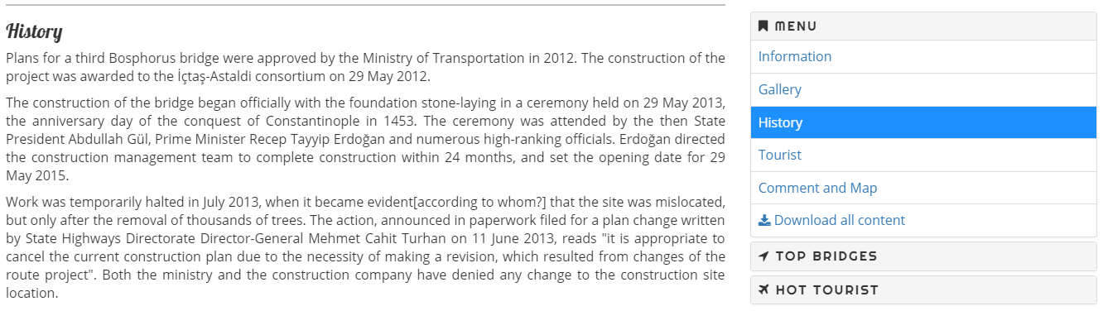

**Bridge - selection:**

Users click on the image or name of the bridge that they would like to read about. The image is shown next to the name.

***Figure – 7***

*(Name selection)*

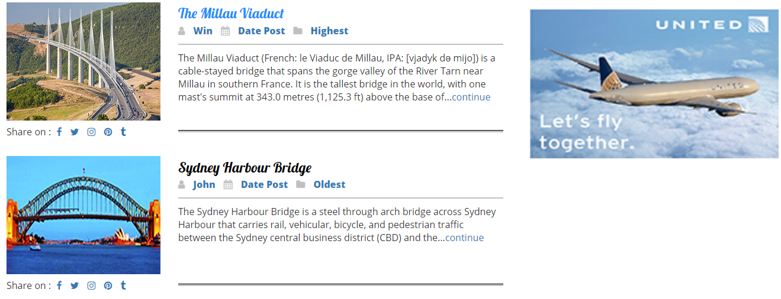

***Figure – 8***

*(Image selection)*

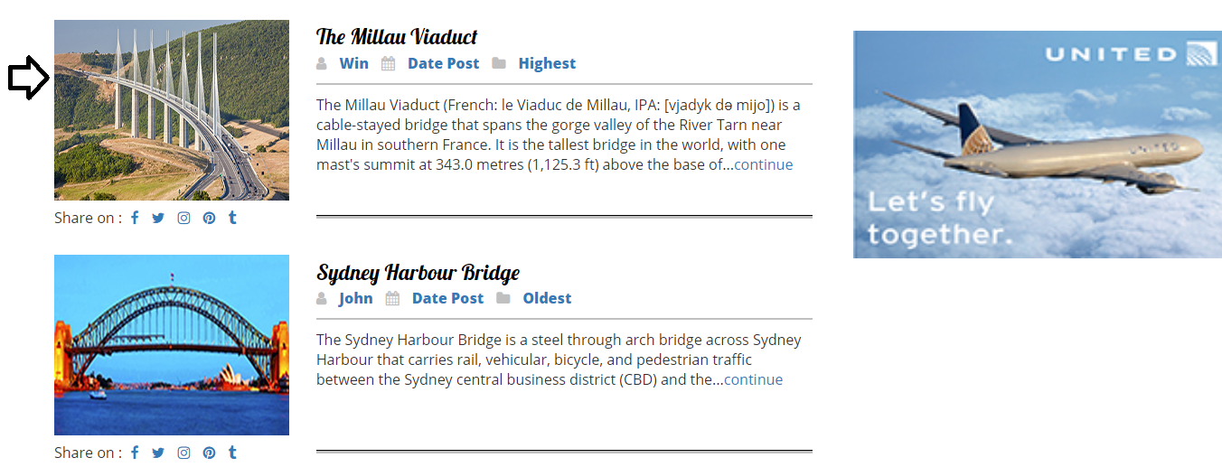

**Content download:**

Users click on Download all content from sub – menu.

***Figure – 9***

*(Download content for Danyang – Kunshan Grand Bridge)*

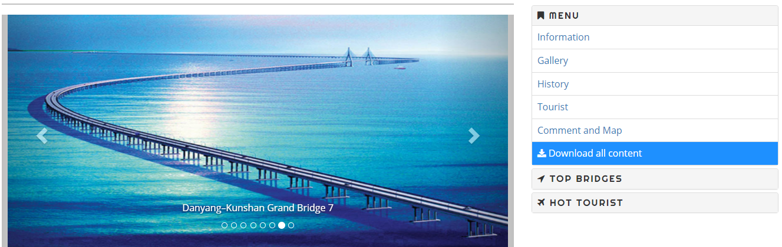

**Feedback:**

Users fill in the comment form then summit to website.

***Figure – 10***

*(Giving comments for better improvement)*

